1 run...

Downloading: 100%

411/411 [00:00<00:00, 14.5kB/s]

Downloading: 100%

263M/263M [00:11<00:00, 23.5MB/s]

training 1 epoch...

1381.9617331027985 seconds used......

1 training finished! average train loss: 0.29641106797901523

evaluating...

Confusion matrix, without normalization

[[ 371 330 321]

[ 193 4988 226]

[ 105 327 10333]]

Normalized confusion matrix

[[0.3630137 0.32289628 0.31409002]

[0.03569447 0.92250786 0.04179767]

[0.00975383 0.03037622 0.95986995]]

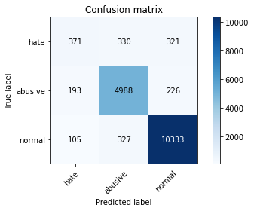

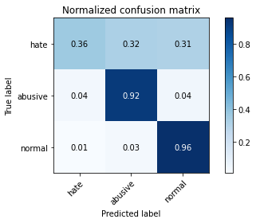

precision recall f1-score support

hate 0.55 0.36 0.44 1022

abusive 0.88 0.92 0.90 5407

normal 0.95 0.96 0.95 10765

accuracy 0.91 17194

macro avg 0.80 0.75 0.77 17194

weighted avg 0.91 0.91 0.91 17194

average eval_loss: 0.2724225740100062, accuracy: 0.9126439455624055

training 2 epoch...

1382.116622209549 seconds used......

2 training finished! average train loss: 0.23465073761537805

evaluating...

Confusion matrix, without normalization

[[ 234 486 302]

[ 45 5194 168]

[ 89 469 10207]]

Normalized confusion matrix

[[0.22896282 0.47553816 0.29549902]

[0.00832254 0.96060662 0.03107083]

[0.00826753 0.04356712 0.94816535]]

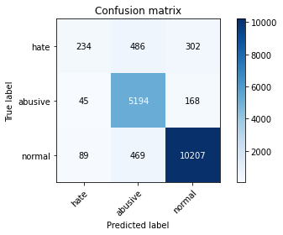

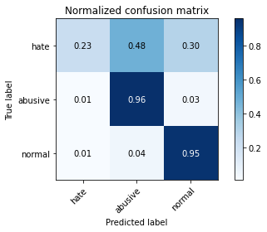

precision recall f1-score support

hate 0.64 0.23 0.34 1022

abusive 0.84 0.96 0.90 5407

normal 0.96 0.95 0.95 10765

accuracy 0.91 17194

macro avg 0.81 0.71 0.73 17194

weighted avg 0.90 0.91 0.90 17194

average eval_loss: 0.2790026094114711, accuracy: 0.9093288356403396

training 3 epoch...

1383.0958864688873 seconds used......

3 training finished! average train loss: 0.17534090770887353

evaluating...

Confusion matrix, without normalization

[[ 420 340 262]

[ 219 4955 233]

[ 277 364 10124]]

Normalized confusion matrix

[[0.4109589 0.33268102 0.25636008]

[0.04050305 0.91640466 0.04309229]

[0.02573154 0.03381328 0.94045518]]

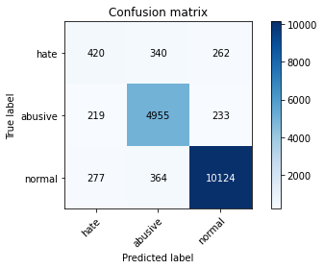

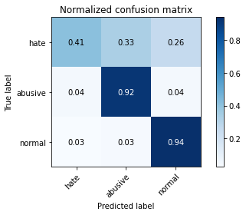

precision recall f1-score support

hate 0.46 0.41 0.43 1022

abusive 0.88 0.92 0.90 5407

normal 0.95 0.94 0.95 10765

accuracy 0.90 17194

macro avg 0.76 0.76 0.76 17194

weighted avg 0.90 0.90 0.90 17194

average eval_loss: 0.3113247136542097, accuracy: 0.9014190996859369

training 4 epoch...

1382.4452142715454 seconds used......

4 training finished! average train loss: 0.1197330337730982

evaluating...

Confusion matrix, without normalization

[[ 399 351 272]

[ 243 4966 198]

[ 318 407 10040]]

Normalized confusion matrix

[[0.39041096 0.34344423 0.26614481]

[0.04494174 0.91843906 0.0366192 ]

[0.02954018 0.03780771 0.93265211]]

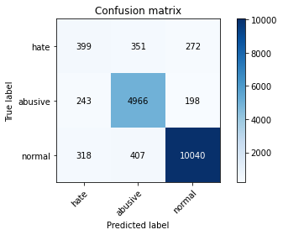

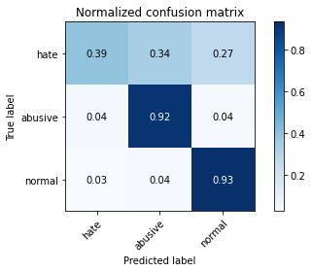

precision recall f1-score support

hate 0.42 0.39 0.40 1022

abusive 0.87 0.92 0.89 5407

normal 0.96 0.93 0.94 10765

accuracy 0.90 17194

macro avg 0.75 0.75 0.75 17194

weighted avg 0.90 0.90 0.90 17194

average eval_loss: 0.3992984486803369, accuracy: 0.8959520763056881

training 5 epoch...

1381.676513671875 seconds used......

5 training finished! average train loss: 0.08548336818235315

evaluating...

Confusion matrix, without normalization

[[ 404 315 303]

[ 301 4785 321]

[ 256 313 10196]]

Normalized confusion matrix

[[0.39530333 0.30821918 0.2964775 ]

[0.05566858 0.88496394 0.05936749]

[0.02378077 0.02907571 0.94714352]]

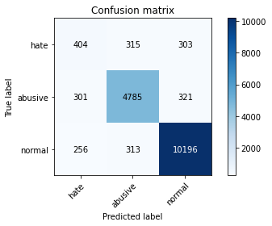

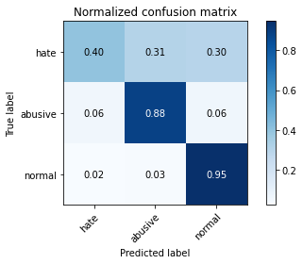

precision recall f1-score support

hate 0.42 0.40 0.41 1022

abusive 0.88 0.88 0.88 5407

normal 0.94 0.95 0.94 10765

accuracy 0.89 17194

macro avg 0.75 0.74 0.75 17194

weighted avg 0.89 0.89 0.89 17194

average eval_loss: 0.4608320876192518, accuracy: 0.8947888798418053

2 run...

training 1 epoch...